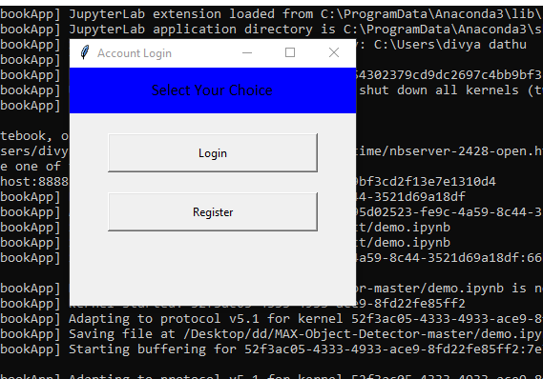





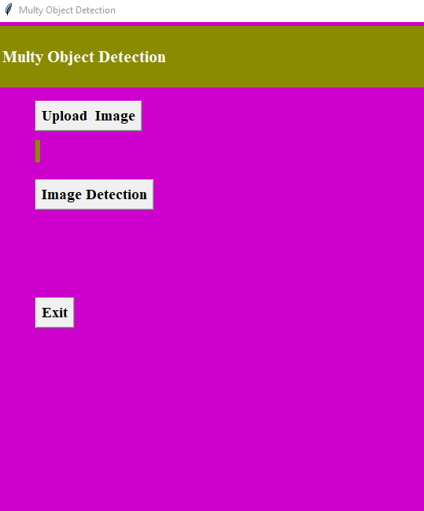

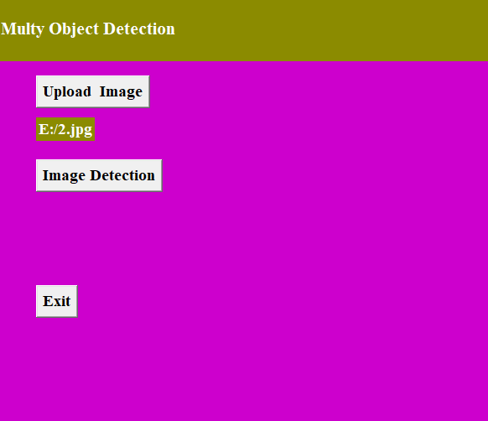

Image Path: C:/Users/divya dathu/Desktop/dd/multi object/2.jpg

{

"status": "ok",

"predictions": [

{

"label_id": "1",

"label": "person",

"probability": 0.905836284160614,

"detection_box": [

0.07806757092475891,

0.30098026990890503,

0.9207696914672852,

0.6773121953010559

]

},

{

"label_id": "1",

"label": "person",

"probability": 0.8034237623214722,

"detection_box": [

0.08797425031661987,

0.6068599224090576,

0.9346213936805725,

0.9672766923904419

]

},

{

"label_id": "1",

"label": "person",

"probability": 0.7375385165214539,

"detection_box": [

0.1635270118713379,

0.04045720398426056,

0.9203600883483887,

0.35440272092819214

]

}

]

}

